 Invention Disclosure Format (IDF)-B | Document No. | 02-IPR-R003
 | Issue No/Date | 2/01.02.2024
 | Amd. No/Date | 0/00.00.0000

- Title of the invention:

System and Method for Automated Detection of Functional Data Overreach in Privacy Policies Using a Formal Functional Data Ontology and Semantic Graph Querying

- Field /Area of invention:

The invention relates to software compliance and natural language processing, and more specifically to computer-implemented systems and methods for auditing digital privacy disclosures against the functional data requirements of an application, using formal ontologies, RDF knowledge graphs and large language models. Application areas are data-protection compliance (data minimisation, GDPR Article 5(1)(c)), app-store vetting and privacy engineering.

- Prior Patents and Publications from literature (provide a table summarizing the prior art)

S. No. | Patent / Publication / System | Description | Relevance to the Proposed Invention
1 | VPVet: Vetting Privacy Policies of Virtual Reality Apps, ACM Conference on Computer and Communications Security (CCS), 2024, doi:10.1145/3658644.3690321 | Vets the privacy policies of virtual-reality apps using a data ontology. It checks minimisation compliance by detecting overbroad data types in the policy's own claims, and checks consistency of the policy with app code | Uses an ontology hierarchy of data types, as the proposed invention does for matching. It judges how broad the policy's claims are, not whether the declared data exceeds what each function needs
2 | US 10,204,225 B2 (publication US 2015/0332049 A1), System and method for determining description-to-permission fidelity in mobile applications, Northwestern University; | Uses natural language processing and a learned model to relate an application's store description to the permissions it requests, and flags permissions that the description does not warrant | Closest in concept: it infers the resources a function needs from a description of the functionality. It maps descriptions to Android permissions, not to the data types declared in a privacy policy, and it uses no ontology, no purpose comparison and no policy text
3 | US 9,215,548 B2 (publication US 2012/0072991 A1), Methods and systems for rating privacy risk of applications for smart phones and other mobile platforms; | Validates the intent of a mobile application against the data and functions it actually accesses, assigns a privacy-risk score and reports it to users | Compares intended purpose with observed access. It works from application code and behaviour, not from policy disclosures, and has no ontology or per-function expected data
4 | Indian Patent Application No. 202541122641, Dynamic Ontology Builder for Contextual Data Classification | Builds and evolves an ontology automatically from unstructured and semi-structured data using natural-language processing, relational triples and knowledge-graph generation, with a rule-based and probabilistic reasoning layer and a feedback-learning loop, to classify contextual data. | Shares the use of an ontology and a knowledge graph with a reasoning layer. It is domain-independent and self-evolving, and is not directed at privacy. The proposed invention uses a fixed, purpose-built ontology with a data-type taxonomy, SPARQL queries over it, and a deterministic decision function to decide overreach.
5 | Indian Patent Application No. 202611100307, AI-based system and method for right-to-privacy compliance in legal data processing | Detects personal and sensitive information in legal documents with natural-language processing and entity recognition, compares it with machine-readable privacy rules, evaluates purpose, lawful basis, consent, requester authority and data necessity, and returns a reasoned result (permit, restrict, refer or deny). Information not necessary for the approved purpose is masked or redacted, and an audit record is kept. | It decides whether processing exceeds what an approved purpose needs. It works on legal documents and data-processing requests and finds personal data inside a record. It does not analyse an application’s privacy policy, has no per-function expected-data baseline and no data-type ontology.
6 | Oltramari et al., PrivOnto: A Semantic Framework for the Analysis of Privacy Policies, Semantic Web, 9(2):185-203, 2018, doi:10.3233/SW-170283 | An ontology and 57 SPARQL queries over more than 23,000 annotated data practices from 115 privacy policies, to answer privacy questions and support regulators. | Shares the use of an ontology and SPARQL over policies. It represents what policies say; it has no per-function expected-data model and no overreach decision.
7 | Zimmeck et al., MAPS: Scaling Privacy Compliance Analysis to a Million Apps, Proceedings on Privacy Enhancing Technologies, 2019(3):66-86, doi:10.2478/popets-2019-0037 | Combines code analysis and machine learning to compare the practices of 1,035,853 Android apps with their privacy policies, and finds that policies are often silent on practices performed by the apps. | Detects undisclosed behaviour (code against policy). It does not decide whether disclosed collection is necessary for the application’s functions.
8 | Zhou et al., POLICYCOMP: Counterpart Comparison of Privacy Policies Uncovers Overbroad Personal Data Collection Practices, USENIX Security Symposium, 2023 | Asks whether the personal data collection practices in an app’s privacy policy are overbroad (data minimisation). It compares each policy with the policies of counterpart apps and flagged 48.29% of the practices in 10,042 policies as overbroad. | Necessity is judged against what peer apps declare, a statistical norm. The proposed invention judges it against an explicit expected-data baseline for each application function, so it can assess an app with no peers and every verdict traces to a function and a rule.

- Summary and background of the invention (Address the gap / Novelty)

Background:
Data-protection law requires that collection be limited to what is needed. The GDPR requires personal data to be adequate, relevant and limited to what is necessary for the purposes (Article 5(1)(c)). India's Digital Personal Data Protection Act, 2023 (section 6(1)) requires that consent be limited to the personal data necessary for the specified purpose. Mobile and web privacy policies, however, are long, legally dense and rarely read, and regulators cannot inspect them at scale.

Gap:

- No functional context. Text-analysis tools extract what data a policy says it collects. They do not evaluate whether that collection is needed by the features the application actually provides.
- No shared semantics. Policies describe the same data in varied terms ("precise geolocation", "GPS coordinates", "physical location"). Without a controlled vocabulary tied to functional need, these cannot be validated systematically.
- Opaque decisions. Machine-learning risk scores rarely give a traceable chain from an application function to a specific policy clause.
- Code-analysis tools do not map to disclosures. Static and dynamic app analysis observes behaviour, but does not compare it against a formal model of what each feature needs.

Novelty:
- A domain ontology for functional data overreach that relates application functions, expected data items, declared disclosures, purposes, necessity levels and overreach findings in one schema, together with a taxonomy of data types used for subsumption-based matching.
- Detection in both directions. Expected data is checked against the policy, and declared data that no function needs is checked against the functional baseline, with an ancillary baseline for data every application legitimately needs.
- Baseline synthesis isolated from the policy text. The functional baseline comes from a curated dataset first. When none exists, an LLM generates it from the application's functional context only, and the prompt never receives the privacy policy, which prevents the policy from biasing what counts as "necessary".
- Conservative omission handling. A policy silence, an unclassified purpose, or a declaration that merely lies outside an incomplete baseline is treated as unverified (AMBIGUOUS), never as proof of compliance or of violation.
- A single explainable decision function fed by two evidence paths (relational comparison and SPARQL queries over the ontology's class hierarchy), verified to give the same verdicts on a synthetic suite.

- Objective(s) of Invention

- To define a formal Functional Data Ontology (FDO) that captures functions, expected data, declared data, purposes, necessity and overreach.
- To automate extraction of data-collection claims from privacy policies and normalise them to canonical data-type and purpose categories.
- To compare declared collection against a functional baseline and detect over-collection at the level of individual data items.
- To produce explainable results: each verdict gives its rule, confidence and supporting policy text.
- To avoid false accusations by treating missing or weak evidence as ambiguous.
- To give auditors an interactive dashboard for on-demand assessment.

- Working principle of the invent (in brief)

For an application, the system first obtains the expected data for each function (for example, a navigation app's "show route" function expects precise location, purpose: navigation). It then reads the application's privacy policy, extracts atomic statements (data type, purpose, entity, sharing, retention, verbatim text) and filters out operational noise. Each expected-data item is paired with the best-matching policy evidence, where a match means the declared data type is equal to, broader than or narrower than the expected type in a data-type hierarchy (for example, location contains precise location). Three signals are then computed: data match (exact, hierarchical or none), purpose compatibility (compatible, incompatible or unknown) and evidence status. An ordered rule set turns these signals into NOT_FDO, FDO or AMBIGUOUS. In the reverse direction, every declared data item that no expected item covers is examined as a possible overreach, unless it is ancillary data that any application legitimately needs. The same data can also be projected into an RDF graph, published to a triple store and queried with SPARQL; the query bindings are converted into the same decision inputs.

- Description of the invention in detail (Include drawing and or photograph as needed)
7.1 System architecture (Figure 1)
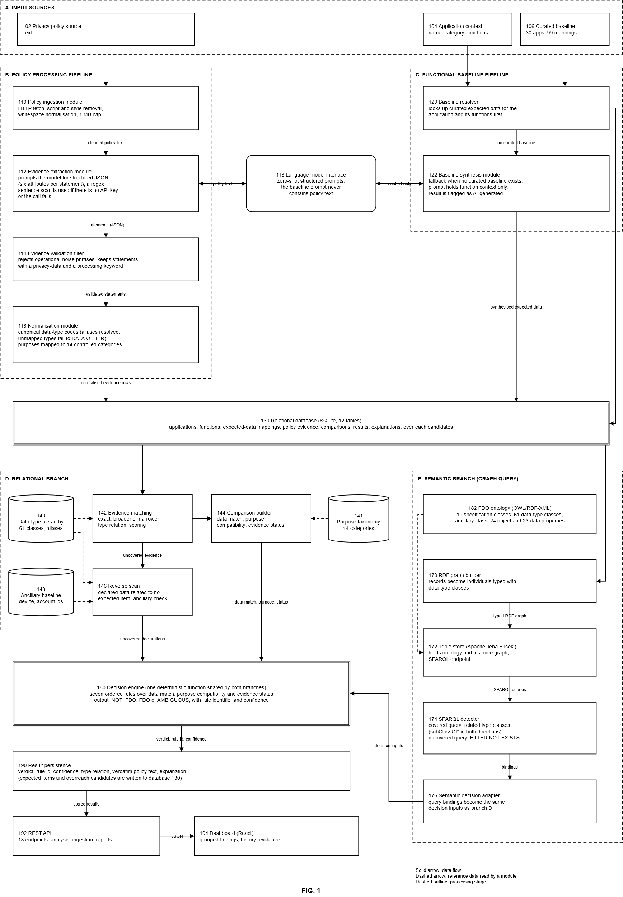

FIG. 1 shows the system as five processing groups feeding one decision engine, with a relational database in the middle. Each box carries a reference numeral that you can cite in the description. A solid arrow means data flows from one module to another. A dashed arrow means a module reads reference data from a store. A dashed outline groups modules that belong to one processing stage.
- Input sources (102, 104, 106)
The system takes three inputs. Box 102 is the privacy policy of the application, supplied either as a URL or as policy text captured earlier as a snapshot. Box 104 is the application context: the application name, its category and the list of its functions. Box 106 is the curated baseline dataset, which currently holds 30 applications and 99 expected functional mappings. The policy input goes to the policy pipeline in group B. The application context and the curated baseline go to the baseline pipeline in group C.

- Policy processing pipeline (110, 112, 114, 116)
The policy ingestion module 110 fetches the policy page over HTTP, removes script and style content, normalises whitespace and caps the document at 1 MB. Its output is cleaned policy text. The evidence extraction module 112 sends this text to the language-model interface 118 with a structured prompt and receives structured JSON. Each statement in the JSON has six attributes: data type, purpose, entity, sharing, retention and the verbatim sentence of the policy that supports it. If no API key is available, or the model call fails, module 112 falls back to a regex sentence scan with keyword matching, which gives sparser results. The evidence validation filter 114 rejects statements that match operational-noise phrases and keeps only statements that contain both a privacy-data keyword and a processing keyword. The normalisation module 116 then converts each validated statement into a canonical form. Data types are mapped to codes such as DATA.LOCATION.PRECISE (aliases are resolved and unmapped types fall to DATA.OTHER), and purposes are mapped to one of 14 controlled categories. The output of group B is a set of normalised evidence rows, which are written to the relational database 130.

- Functional baseline pipeline (120, 122)
The baseline resolver 120 first looks up curated expected data for the application and its functions in the curated dataset. If a curated baseline exists, it is written to database 130 as expected-data items (function, data type, necessity, expected purpose, justification). If none exists, the baseline synthesis module 122 generates the expected data with the language model, through interface 118. The prompt for this step contains only the application context and function descriptions. It never contains policy text, so the policy cannot influence what counts as necessary. This is why the arrow between 122 and 118 is labelled “context only”, and why box 118 repeats the rule. The synthesised items are written to database 130 and marked as AI-generated.

Language-model interface (118)
Box 118 is shared by modules 112 and 122. Module 112 sends it policy text and receives structured statements. Module 122 sends it function context only and receives expected-data items. The two arrows are double-headed because each is a prompt followed by a response.

Relational database (130)
Database 130 (SQLite, 12 tables) holds the applications, functions, expected-data mappings, policy evidence, comparisons, results, explanations and overreach candidates. It is the common point between the two input pipelines and the two analysis branches. It receives the evidence rows from group B and the expected-data items from group C, and it supplies both to the branches below.

D. Relational branch (140, 141, 142, 144, 146, 148)
The evidence matching module 142 reads expected-data items and evidence rows from database 130. For each expected item it looks for evidence whose data type is equal to, broader than or narrower than the expected type, using the data-type hierarchy 140 (61 classes, with aliases). Sibling types such as precise and approximate location do not match. Candidates are scored with a heuristic of at most 116 points, and the best unique candidate is selected. The selected pair and its type relation go to the comparison builder 144. Module 144 determines the data match (exact, hierarchical or none), the purpose compatibility (compatible, incompatible or unknown, using the 14-category purpose taxonomy 141) and the evidence status. Evidence that no expected item covers goes to the reverse scan 146 along the arrow labelled “uncovered evidence”. Module 146 checks each such declaration against the ancillary baseline 148, which holds data that any application legitimately needs, such as device and account identifiers used for security or service operation. Module 146 also reads the hierarchy 140 to decide whether a declaration is related to any expected item. The outputs of 144 and 146 are decision inputs, passed to the decision engine 160.

E. Semantic branch (170, 172, 174, 176, 182)
The RDF graph builder 170 reads records from database 130 and turns them into RDF individuals typed with the data-type classes of the ontology. Those classes are defined in the FDO ontology 182, which holds 19 specification classes, 61 data-type classes, an ancillary class, 24 object properties and 23 data properties. The ontology is loaded into the triple store 172 (Apache Jena Fuseki) together with the typed instance graph. The SPARQL detector 174 runs two queries against 172. The covered query pairs each expected item with each declared item whose type classes are related by rdfs:subClassOf* in either direction, and returns both purposes. The uncovered query uses FILTER NOT EXISTS to return declared items related to no expected item. The semantic decision adapter 176 converts the query bindings into the same decision inputs that branch D produces, and passes them to decision engine 160. If the triple store is not running, this branch is skipped and branch D still completes.

Decision engine (160)
Box 160 is one deterministic function shared by both branches. It evaluates seven ordered rules over the data match, the purpose compatibility and the evidence status. The rules cover: no evidence, insufficient evidence, an unknown purpose, a data match with a compatible purpose, a data match with an incompatible purpose, no data match, and everything else. The output for each item is one of three verdicts (NOT_FDO, FDO or AMBIGUOUS) with a rule identifier and a confidence value. Declared data that no expected item covers is judged by the same function: an incompatible purpose gives FDO, a compatible or unknown purpose gives AMBIGUOUS, and ancillary data gives NOT_FDO.

Output (190, 192, 194)
The result persistence module 190 stores the verdict, rule identifier, confidence, type relation (exact, broader or narrower), the verbatim policy text that supports the verdict, and an explanation. Expected-item results and overreach candidates are written back to database 130. The REST API 192 exposes the analysis, ingestion and reporting functions through 13 endpoints and returns JSON. The React dashboard 194 reads that JSON and shows findings grouped by function, the history of past analyses and the supporting evidence.

7.2 Functional baseline layer
The baseline is a set of tuples (function, data type, necessity, expected purpose, justification). It is resolved in two steps:
- Curated lookup from a dataset of 30 applications in 4 categories with 99 expected functional mappings.
- LLM synthesis fallback for applications not in the dataset. The prompt contains only the application's functional context and does not receive any policy text. Results are stored with their source marked as AI-generated.

7.3 Policy ingestion, extraction and normalisation
- Ingestion: the policy page is fetched over HTTP and stripped of script and style content, with whitespace normalised and a size cap of 1,000,000 bytes.
- Extraction: a large language model (Gemini 3.5 Flash Lite in the prototype, zero-shot, no fine-tuning) returns structured JSON with six attributes per statement: data type, purpose, entity, sharing, retention and verbatim evidence text. If no API key is available or the call fails, a deterministic regex sentence splitter with keyword matching is used.
- Validation: statements are rejected if they match operational-noise phrases or do not contain both a privacy-data keyword and a processing keyword.
- Normalisation: data types map to canonical tokens (for example DATA.LOCATION.PRECISE; unmapped types fall to DATA.OTHER) and purposes map to 14 controlled purpose categories.

7.4 Evidence matching

Candidate evidence for an expected-data item must have a data type that is equal to it, an ancestor of it (broader evidence) or a descendant of it (narrower evidence) in a hierarchy of data types, so that evidence about "location" can support an expectation of "precise location". Sibling types, such as precise and approximate location, do not match, and a coarse type such as account information does not support an unrelated type such as location. Candidates are scored with a heuristic (maximum 116 points; weights in Annex B): a base score, a bonus for an exact type match, a large bonus when the purposes are compatible, a bonus when the function is referenced in the evidence text, a small bonus for extraction status and a confidence-weighted term. The highest-scoring unique candidate is selected; ties, or an incompatible best candidate among several, leave the comparison ambiguous.

7.5 Decision function
One deterministic function evaluates the signals in the following order:
Rule | Condition | Verdict | Confidence
1 | No declared evidence | AMBIGUOUS | 0.30
2 | Evidence insufficient, unknown or not extracted | AMBIGUOUS | 0.40
3 | Purpose compatibility unknown (an unclassified purpose) | AMBIGUOUS | 0.40
4 | Data match (exact or hierarchical) and compatible purpose | NOT_FDO | 0.90 (lower when the evidence is broader than expected)
5 | Data match (exact or hierarchical) and incompatible purpose | FDO (purpose overreach) | 0.85
6 | No data match | FDO (data-type overreach) | 0.80
7 | All other combinations | AMBIGUOUS | 0.50

Declared data that no expected item covers (found by a reverse scan of the evidence) is judged with the same function: a purpose incompatible with every expected purpose of the application gives FDO; a compatible purpose gives AMBIGUOUS, because the data may simply be missing from the functional baseline; an unknown purpose gives AMBIGUOUS; and data in the ancillary baseline (such as device or account identifiers used for security or service operation) gives NOT_FDO.
This function is shared by the relational and semantic branches, so a finding from either path is explained in the same terms. Current implementation note: the functional-relationship signal currently records only that the evidence is linked to the function under evaluation; it does not yet test whether the function's description supports the claim.
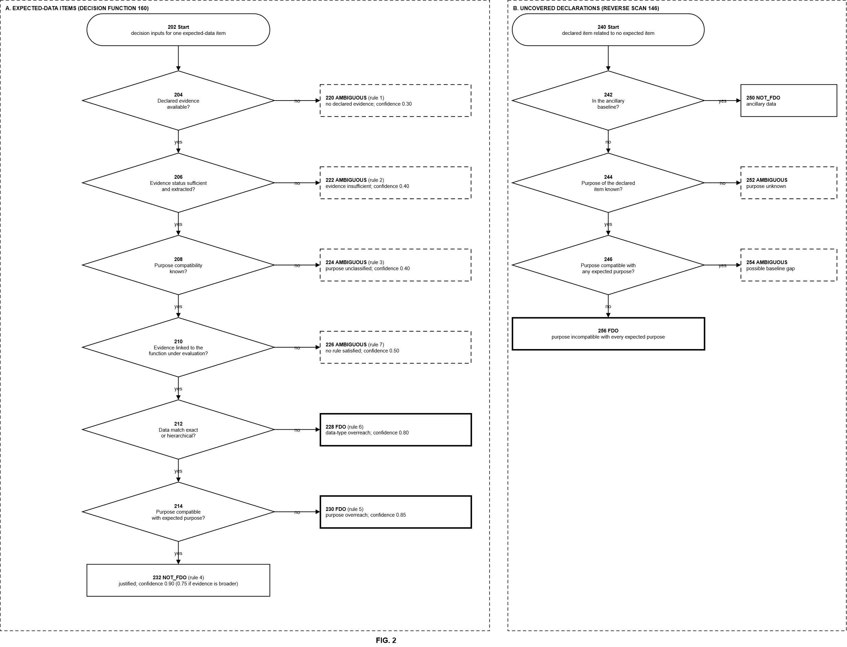
FIG. 2 shows how the decision engine 160 of FIG. 1 turns the signals for one item into a verdict. Panel A handles an expected-data item, which is a piece of data that an application function needs. Panel B handles an uncovered declaration, which is a data item declared in the privacy policy that no expected-data item covers (found by the reverse scan 146). Both panels use the same function, and every outcome carries a rule identifier, a confidence value and an explanation.

Panel A. Decision inputs 202 are the signals computed by the comparison builder 144 for one expected-data item: data match, purpose compatibility, evidence status and whether the evidence is linked to the function. The tests are applied in a fixed order, and the first test that fails ends the evaluation.

Test 204 asks whether declared evidence is available. If it is not, the outcome 220 is AMBIGUOUS with confidence 0.30 (rule 1), because the system cannot judge an item that the policy does not mention.

Test 206 asks whether the evidence status is sufficient and extracted. If the evidence is insufficient, unknown or not extracted, the outcome 222 is AMBIGUOUS with confidence 0.40 (rule 2).

Test 208 asks whether the purpose compatibility is known. An unclassified purpose cannot be compared with the expected purpose, so the outcome 224 is AMBIGUOUS with confidence 0.40 (rule 3). This stops the system from accusing an application because its policy uses a purpose phrase that the taxonomy does not yet cover.

Test 210 asks whether the evidence is linked to the function under evaluation. If it is not, no later rule can apply and the outcome 226 is AMBIGUOUS with confidence 0.50 (rule 7). In the current implementation the link is set whenever evidence exists, so this branch acts as a safety net.

Test 212 asks whether the data match is exact or hierarchical. A hierarchical match means the declared type is broader or narrower than the expected type in the data-type hierarchy (FIG. 3). If there is no data match, the policy declares a different type of data for this function, and the outcome 228 is FDO (data-type overreach) with confidence 0.80 (rule 6).

Test 214 asks whether the declared purpose is compatible with the expected purpose. If it is, the outcome 232 is NOT_FDO with confidence 0.90 (rule 4); the confidence is lowered to 0.75 when the evidence is broader than the expected type. If the purpose is not compatible, the outcome 230 is FDO (purpose overreach) with confidence 0.85 (rule 5).

Panel B. Start 240 is a declared item that the reverse scan found to be related to no expected item of the application. The same decision function judges it as follows.

Test 242 asks whether the item belongs to the ancillary baseline 148, which holds data that any application legitimately needs (for example device and account identifiers used for security or service operation). If so, the outcome 250 is NOT_FDO.

Test 244 asks whether the purpose of the declared item is known. If it is not, the outcome 252 is AMBIGUOUS, because the purpose cannot be tested.

Test 246 asks whether the purpose is compatible with any expected purpose of the application. If it is, the outcome 254 is AMBIGUOUS (possible baseline gap): the item is not in the baseline, but its purpose matches what the application does, so the baseline may simply be incomplete. If the purpose is incompatible with every expected purpose, the outcome 256 is FDO.
Border styles in both panels show the verdict: a solid border for NOT_FDO, a thick border for FDO and a dashed border for AMBIGUOUS.

7.6 Functional Data Ontology and semantic branch

The ontology (fdo:) has 19 specification classes (for example Application, Function, ExpectedData, DeclaredData, PrivacyPolicy, PolicyClause, Overreach and Risk), 24 object properties and 23 data properties, with cardinality and mandatory-property constraints. In addition, a taxonomy of 61 data-type classes (fdo:DataType_*), arranged with rdfs:subClassOf beneath fdo:DataType, encodes that, for example, precise location is a kind of location. An fdo:AncillaryData class marks data that any application legitimately needs, such as device and account identifiers used for security or service operation. In total the serialised OWL/RDF-XML file declares 82 named classes.
In the semantic branch, relational records are mapped to RDF individuals under the ontology, each typed with its data-type class, and published to an Apache Jena Fuseki triple store. Two SPARQL queries then run. A covered query pairs each expected-data item with each declared-data item whose type class is related to it by rdfs:subClassOf* in either direction, and returns both purposes. An uncovered query uses FILTER NOT EXISTS to return declared data whose type is related to no expected item of the application. An adapter converts the bindings into the same decision inputs that the relational branch builds, so both branches are evaluated by the same decision function. If the triple store is unavailable, the semantic branch is skipped and the relational branch still completes.
Implementation note: the triple store is configured with an OWL rule reasoner, but the prototype does not use its inferences. Decisions come from SPARQL property-path queries over the class hierarchy and the Python decision function. The invention should therefore be described as ontology-grounded graph querying, not automated OWL reasoning.
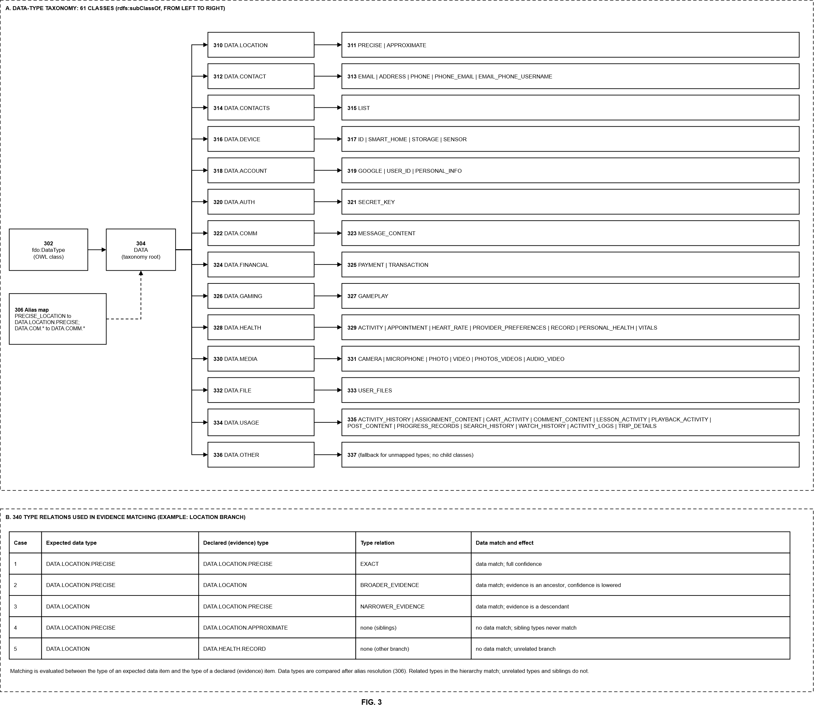

FIG. 3 shows the data-type taxonomy that the system uses to compare an expected data type with a declared data type. Panel A shows the taxonomy and panel B shows how the hierarchy is used when matching.

Panel A. The class 302 (fdo:DataType) is the parent of all data types in the ontology. Beneath it, the root 304 (DATA) groups all the data types that the system recognises. The branches 310 to 336 are the 14 main groups: location, contact, contacts, device, account, authentication, communication, financial, gaming, health, media, file and usage data, plus an OTHER group. Each branch is followed by its child types (311 to 335), which are shown to the right of the branch, separated by vertical bars. For example, the branch 310 (DATA.LOCATION) has the children PRECISE and APPROXIMATE, so DATA.LOCATION.PRECISE is a kind of DATA.LOCATION. In total the taxonomy has 61 classes: the root, 14 branches and 46 child types. The branch 336 (DATA.OTHER) is the fallback for data types that the normalisation module 116 cannot map; it has no children.

The alias map 306 resolves shorthand and variant codes to canonical codes before any comparison, so that the same data is never counted as two different types. For example, PRECISE_LOCATION becomes DATA.LOCATION.PRECISE, and DATA.COM.* codes become DATA.COMM.*.

In FIG. 1 this taxonomy is the hierarchy 140, and the same classes are written to the ontology 182 as rdfs:subClassOf relations, so the relational branch and the semantic branch use identical relations.

Panel B. The table 340 shows five example cases from the location branch. In each, the system compares the type of an expected data item with the type of a declared (evidence) item.

Case 1: both types are DATA.LOCATION.PRECISE. The relation is EXACT and the data match is full.

Case 2: the expected type is DATA.LOCATION.PRECISE and the declared type is DATA.LOCATION. The declared type is an ancestor of the expected type, so the relation is BROADER_EVIDENCE. This is a data match, but the confidence of a NOT_FDO verdict is lowered, because the policy does not say how precise the location is.

Case 3: the expected type is DATA.LOCATION and the declared type is DATA.LOCATION.PRECISE. The declared type is a descendant of the expected type, so the relation is NARROWER_EVIDENCE and it is a data match.

Case 4: the expected type is DATA.LOCATION.PRECISE and the declared type is DATA.LOCATION.APPROXIMATE. These types are siblings under DATA.LOCATION, so there is no relation and no data match.

Case 5: the expected type is DATA.LOCATION and the declared type is DATA.HEALTH.RECORD. The types are in different branches, so there is no data match.

7.7 Output and explainability
Each result stores the verdict, rule identifier, confidence, the matched policy evidence (verbatim text), the type relation used (exact, broader or narrower) and an explanation. Declared data that the functional baseline does not cover is stored separately as overreach candidates with the same fields. Results are exposed through 13 REST endpoints and shown in a React dashboard that groups semantic findings by function and keeps a history of past analyses. Data is persisted in a relational database with 12 tables.

7.8 Technical implementation and technical effect
The invention is implemented as a system comprising a processor and a memory that stores instructions, a network interface, a language-model interface, an RDF triple store with a SPARQL endpoint, and a relational database. The instructions cause the processor to:
- retrieve a policy document over the network, remove markup and bound its size;
- obtain the expected-data baseline of each application function, from a curated dataset or from a language model prompted with the functional context only;
- extract structured statements from the policy and normalise their data types and purposes to controlled vocabularies;
- match declared data to expected data using a data-type hierarchy, recording whether the evidence is exact, broader or narrower;
- build an RDF graph whose data nodes are typed with the data-type classes of the ontology, and publish it to the triple store;
- execute a covered query and an uncovered query that use rdfs:subClassOf* property paths, and convert the bindings into decision inputs;
- evaluate a deterministic rule function that returns a verdict, rule identifier and confidence for expected items and for uncovered declarations; and
- persist the results and expose them through a programmatic interface and a dashboard.

The subject matter is not a computer program per se. It controls a specific data-processing pipeline spanning network retrieval, language-model inference that is isolated from the policy text, typed graph construction and graph querying, and it produces a technical output (classified findings with traceable evidence) that cannot be read directly from the policy text.

Technical effects:
- On the project benchmark, the pipeline flagged 6.5% of mappings as overreach, against 85% for a keyword-presence baseline (Section 8.2), so it produces far fewer false accusations.
- Isolating the baseline-generation prompt from the policy text prevents the policy from biasing what counts as necessary.
- The relational and graph-query paths return identical verdicts on a synthetic suite (Section 8.4), so findings are reproducible and explainable.
- Hierarchy-aware matching lets coarse policy statements support finer expectations without a separate mapping table for every pair of types.

- Experimental validation results:
The evaluation reported here is preliminary. It measures the decision layer on the project's curated dataset, describes the error analysis that shaped the final design, and states the status of automated policy extraction. Quantitative evaluation of LLM-based extraction and of detection on real extracted evidence is in progress and is not claimed here.

8.1 Dataset and benchmark
- Curated dataset: 30 applications in 15 categories, 99 expected functional mappings and 30 policy records.
- Benchmark ground truth: 93 mappings across 29 applications carry final human labels (Stage 4E / Stage 6 adjudication): 60 NOT_FDO, 33 AMBIGUOUS and 0 FDO. Because the benchmark lists what each function needs, it contains no confirmed overreach cases.
- Evidence used: the curated evidence rows stored in the database (34 rows covering 19 of the 29 applications, prepared during dataset construction). These rows are not the output of the automated extractor.
- Methods compared: the relational pipeline, the semantic (SPARQL) branch, and two simple baselines. Baseline B1 flags FDO whenever the expected data type is absent from the policy evidence. Baseline B2 uses the data-type match alone and ignores purpose.
- Measures: accuracy against the human labels, the share of mappings flagged FDO, and confusion matrices. FDO precision and recall are undefined because the benchmark has no FDO-positive labels. Cohen's kappa for the final outcome labels cannot be computed because paired annotator outcome labels do not exist.

8.2 Initial decision-layer results (before the design corrections)
Method | Accuracy (93 mappings) | Flagged FDO | Predicted AMBIGUOUS
Relational pipeline | 0.323 | 6 (6.5%) | 90.3%
Semantic branch | 0.140 | 58 (62%) | not computed
Baseline B1 (type presence) | 0.075 | 79 (85%) | 0%
Baseline B2 (type match only) | 0.355 | 0 | 87.1%

Two observations matter. First, the naive keyword baseline B1 flags 85% of mappings that human annotators judged legitimate or ambiguous, while the relational pipeline flags 6.5%, so the pipeline is far less prone to false accusations. Second, accuracy was low because 79 of the 93 mappings had no matching evidence and were therefore returned as AMBIGUOUS. All 6 FDO verdicts of the relational pipeline were wrong against the labels.

8.3 Error analysis and resulting design changes
The first-run results were diagnosed before any change was made. Each finding below led to a design correction that follows from the system's own principles, not from tuning to the labels. The 93-mapping benchmark was used for this error analysis and is therefore not a held-out test set for the corrected system.

Finding | Design change
Expected data types are fine-grained while stored evidence is coarse, so exact-type matching found no evidence | A data-type hierarchy with exact, broader and narrower matching, also encoded as rdfs:subClassOf classes in the ontology
Unclassified purposes were treated as incompatible, producing false FDO verdicts | An unknown purpose now yields AMBIGUOUS, and the purpose taxonomy was extended to cover the baseline vocabulary
Overreach could not be detected: matching only searched from expected items to evidence | A reverse scan that examines declared data not covered by any expected item
The semantic query paired every expected item with every declared item, so almost anything looked like a mismatch | Two queries (covered and uncovered) using rdfs:subClassOf*, with an adapter feeding the same decision function
Common infrastructure data (device and account identifiers) was flagged as uncovered | An ancillary baseline of data legitimately needed by any application
An uncovered declaration with a compatible purpose is more likely a gap in the baseline than overreach | Such declarations now yield AMBIGUOUS (possible baseline gap)

8.4 Verification of the corrected decision layer
The corrected relational and semantic branches were checked on a synthetic fixture suite of apps with known expected outcomes: exact match, broader evidence, narrower evidence, sibling types, an unrelated declaration, an ancillary declaration, an unknown purpose, no evidence, approximate location declared for navigation, and contacts declared for advertising. Explicit verdicts and confidences are asserted for every case, and the two branches must agree. All pass with the triple store running. The complete automated test suite of the prototype (434 tests) also passes. This verifies the implementation of the rules; it is not a measure of detection accuracy on real policies.

8.5 Status of policy capture and extraction
Snapshots of live policy text, with retrieval time, final URL and SHA-256 hash, were captured for 10 of the 29 benchmark policies (7 fetched automatically, 3 rendered in a browser). The remaining 19 await URL confirmation and manual capture, with product-specific sections required for umbrella policies such as Google, Microsoft and Meta. The LLM extraction pipeline is implemented, but its quantitative evaluation has not yet been run. A run using only the regex fallback found location data and nothing else, which confirms that the fallback is not a substitute for the LLM extractor. Planned next steps are a manually audited sample of extracted rows, and a declared-side benchmark in which two annotators label extracted evidence rows as justified, overreaching or ambiguous, with Cohen's kappa reported.

- What aspect(s) of the invention need(s) protection?

- A computer-implemented method of detecting functional data overreach for an application, comprising: obtaining a functional baseline that lists, for each function of the application, expected data items having a data type and an expected purpose; retrieving a privacy policy of the application and extracting declared data items having a data type and a purpose; determining, for each expected data item, a data match with the declared data items as exact, hierarchical or none, using a data-type hierarchy; determining a purpose compatibility as compatible, incompatible or unknown; and applying ordered rules to the data match, the purpose compatibility and an evidence status to output, for each expected data item, one of a justified, an overreaching and an ambiguous verdict together with a rule identifier and a confidence value.
- The method of claim 1, wherein a declared type that is an ancestor of the expected type is treated as broader evidence, a declared type that is a descendant of the expected type is treated as narrower evidence, sibling types do not match, and the confidence value depends on the relation used.
- The method of claim 1, further comprising a reverse scan that identifies declared data items whose types are related to no expected data item of the application, and judging each such item with the same ordered rules, wherein an item whose purpose is incompatible with every expected purpose is overreaching, an item whose purpose is compatible or unknown is ambiguous, and an item belonging to an ancillary baseline of data needed by any application is justified.
- The method of claim 1, wherein the functional baseline is obtained from a curated dataset or, when none exists, generated by a language model whose input contains functional context of the application and excludes the text of the privacy policy, and is stored as the expected data against which the policy is later compared.
- A system comprising a processor, a memory, a language-model interface and a triple store, the processor being configured to: build an RDF graph in which expected and declared data nodes are typed with data-type classes arranged by subclass relations; execute a covered query pairing expected and declared data whose type classes are related by a subclass path in either direction, and an uncovered query returning declared data related to no expected data; convert the query bindings into decision inputs; and evaluate the decision inputs with the same deterministic rule function that evaluates the decision inputs derived from relational comparison.
- An ontology data structure relating applications, functions, expected data, declared data, purposes, necessity levels, justifications and overreach findings, together with a data-type taxonomy and an ancillary data class, and a constraint set governing cardinality and mandatory properties.
- The method of claim 1, wherein missing evidence, an unclassified purpose, and a declaration that may reflect an incomplete baseline each yield an ambiguous verdict instead of a justified or an overreaching verdict.
- The method of claim 1, wherein each result is stored as a record coupling the verdict to the rule identifier, the confidence value, the type relation used and the verbatim policy text supporting the verdict.
- A non-transitory computer-readable medium storing instructions that, when executed by a processor, cause the processor to perform the method of any of claims 1 to 4, 7 and 8.

Invention Disclosure Format (IDF)-B | Document No. | 02-IPR-R003
 | Issue No/Date | 2/01.02.2024
 | Amd. No/Date | 0/00.00.0000

- What is Technology readiness level of your invention? (Tick the appropriate TRL)

Research |  |  | Development |  |  | Deployment
TRL 1 | TRL 2 | TRL 3 | TRL 4 | TRL 5 | TRL 6 | TRL 7 | TRL 8 | TRL 9
Basic | Technology | Experimental | Technology | Technology | Technology | System | System | Actual system
Principles | concept | proof of | validated in | validated in a | demonstrated | prototype | complete | proven in an
observed | formulated | concept | a lab | relevant | in a relevant | demonstration | and | operational
 |  |  |  | environment | environment | in an | qualified | environment
 |  |  |  | (industrially | (industrially | operational |  | (competitive
 |  |  |  | relevant in | relevant in | environment |  | manufacturing
 |  |  |  | case of key | case of key |  |  | in case of key
 |  |  |  | enabling | enabling |  |  | enabling
 |  |  |  | technologies) | technologies) |  |  | technologies,
 |  |  |  |  |  |  |  | or in space )

----------------------END OF THE DOCUMENT-----------------------------

